**Dental Clinic Services System**

Progress 2

Software Requirement Specification

By

**Kanokwan Maneerat 542115002**

**Worapun Wongkium 542115055**

Department of Software Engineering

College of Arts, Media, and Technology

Chiang Mai University

Project Adviser

______________________________

Miss Pattama Longani

**Software Requirement Specification**

**Revision Table**

|  |  |  |  |  |  |
| --- | --- | --- | --- | --- | --- |
| **Document Name** | **Detail** | **Status** | **Date** | **Viewable** | **Reviewer& Responsible** |
| DCSS – SRS - ver 0.1 | All new | Draft | 09/15/2014 | Adviser | Kanokwan & Worapun |
| DCSS – SRS - ver 0.2 | Double check the words | Draft | 09/30/2014 | Adviser | Kanokwan & Worapun |
| DCSS – SRS - ver 0.3 | Delete and add new URS and SRS | Draft | 10/15/2014 | Adviser | Kanokwan & Worapun |
| DCSS – SRS - ver 0.4 | Change some description | Draft | 10/16/2014 | Adviser | Kanokwan & Worapun |
| DCSS – SRS - ver 0.5 | Correct grammar | Draft | 10/17/2014 | Adviser | Kanokwan & Worapun |
| DCSS – SRS - ver 0.6 | Change some URS and renumbering SRS | Draft | 10/19/2014 | Adviser | Kanokwan & Worapun |
| DCSS – SRS - ver 0.7 | Change some URS and renumbering SRS | Draft | 10/20/2014 | Adviser | Kanokwan & Worapun |
| DCSS – SRS - ver 0.8 | Edit some details | Draft | 10/21/2014 | Adviser | Kanokwan & Worapun |
| DCSS – SRS - ver 1.0 | Edit some details | Release | 10/22/2014 | Adviser | Kanokwan & Worapun |

**Table of Contents**

Chapter One: Introduction 5

1. Introduction 5

1.1 Objectives 5

1.2 Project Scope 5

1.3 User Classes and Characteristics 6

Chapter Two: Overall Description 8

2. Overall Description 8

2.1 Product Perspective 8

2.2 Product Features 8

2.3 Design and Implementation Constraints 8

List of project constraints: 8

Chapter Three: User Requirement 9

3. User requirement 9

3.1 Dental clinic services system URS 9

Feature 4: Patient identification using QR code 9

Feature 5: Dental care consulting and following up 9

Feature 6: A dental clinic information and promotion 9

Feature 7: Cost estimation of dental treatments 9

3.2 Dental clinic services system SRS 11

4. System Features 14

4.1 User requirement specification with system requirement specification 14

4.2 Use Case Diagram 22

4.2.1 Dental clinic services system Use Case for Patient and Visitor 22

4.2.2 Dental clinic services system Use Case for Officer 23

4.2.3 Dental clinic services system Use Case for Dentist 24

4.3 Use case description 25

UC-26:View patients’ information and QR code(mobile) 25

UC-27:View patients’ information and QR code(in website) 27

UC-28:Add patient to a queue 29

UC-29:Reset queue 31

UC-30:Display his/her follow up message 33

UC-31:Post the question for following up with his/her patient 35

UC-32:Display follow up message 37

UC-33:Answer follow up question 39

UC-34:Display follow up message (mobile application) 41

UC-35:Answer follow up question (mobile application) 43

UC-36:Display dental clinic informationand promotion(website**)** 45

UC-37: Display dental clinic information and promotion (mobile application) 45

UC-38:Add dental clinic information 49

UC-39:Edit dental clinic information 51

UC-40:Delete dental clinic information 53

UC-41:Display dental clinic informationand promotion(website**)** 55

UC-42:Estimate the dental treatment cost (website) 57

UC-43:Estimate the dental treatment cost (mobile application) 59

UC-44:Estimate the dental treatment cost (website) 61

UC-45:Add dental treatment 63

UC-46:Edit dental treatment 65

UC-47:Delete dental treatment 67

UC-48:View dental treatment information 69

# Chapter One: Introduction

## 1. Introduction

### 1.1 Objectives

Dental clinic service system consists of a web application and a mobile application which supports iOS7. The system supports English language for people who are patients, officers, or dentists of dental clinics. Furthermore, it offers some features for visitors who would like to gain information about the clinic. This system will reduce officers’ work and help patients save their time. Patients can find information about the dental clinic and personal information using the mobile application as well as the web application. For the visitor who wants to have a dental treatment from the clinic, and the dentist can use the system for checking their appointment schedule. Dental clinic services system integrates the services that are provided by most dental clinics into the web application and the mobile application. By combining all the services into one, the system provides more convenience to dental clinic users as well as staff.

This Software Requirement Specification has described in more detail of each requirement and each function that the system should have. The document includes the scope of the project, the system’s functionalities, user characteristic, functional requirements, and non-functional requirements.

## 1.2 Project Scope

The objective of this software requirement specification is to specify the requirements that the system should fulfill, which are as follows:

* Dental clinic services system provides an application that is accessible via web browser on a computer and also on a mobile phone.
* Dental clinic services system on mobile phone support iOS.
* Dental clinic services system supports English language only.
* Dental clinic services system provides features for dental clinics’ registered user whose are patients, officers and dentists.
* Dental clinic services system assists managing appointments of patients and dentists using the web application and the mobile application.
* Dental clinic services system provides a user authentication for each patient and dentist through dental clinic officers.
* Dental clinic services system provide features for generate QR code to patients from both web application and mobile application
* Dental clinic services system provide features for managing the queue of dental clinic
* Dental clinic services system assists following up treatment between dentist and patient
* Dental clinic services system provide the feature for promoting the clinic also managing those promotion and information
* Dental clinic services system help visitor and patient to predict the cost of dental care

### 1.3 User Classes and Characteristics

The system divides users into 4 groups. Information and characteristics of each group are listed below.

* **Visitor**

This group of user no needs to register to the system to use the services on the website or to use their mobile phone. Visitor is able to:

* Visitor can view dental clinic information and promotion
* Visitor can select dental treatment to estimate the cost
* **Patient**

This group of user needs to be registered to the system at the dental clinic. They will get patientID and password from the clinic to use the services on the website or to use their mobile phone. Patients use their patientID to login. Patients are able to:

* Patient can view their QR code.
* Patient can view follow up question.
* Patient can answer to follow up question.
* Patient can view dental clinic information and promotion.
* Patient can select dental treatment to estimate the cost.
* **Officer**

This group of users has the highest privilege in the system. They are given access to management functions for maintaining the system. Officers are able to:

* Officer can add patient to a queue and reset queue.
* Officer can add information and promotion into the website.
* Officer can edit information and promotion from the website.
* Officer can delete information and promotion from the website.
* Officer can add dental treatment and cost into the website.
* Officer can edit dental treatment and cost from the website.
* Officer can delete dental treatment and cost from the website.
* Officer can view all dental treatment.

**Dentist**

This group of user needs to be registered to the system at the dental clinic. They will register their account at the clinic. Dentist uses their dentistID and password to login to the system to use the services. Dentists are able to:

* Dentist can view their follow up question.
* Dentist can post question to follow up their patient

2. **1.4 Operation Environment**

Dental clinic services system uses web service technology and iOS technology. All the characters must have the Internet connection. Patients who want to use the mobile application must use a smartphone which supports iOS7.

**1.5** **Acronyms and Definitions Acronyms**

**Acronyms**

|  |  |
| --- | --- |
| **Acronyms** | **Stands for** |
| Registered User | Patient, Dentist, and Officer |
| Non-registered User | Visitor |
| PSR | Project Status Report |
| PM | Project Management |
| PMP | Project Management Plan |
| URS | User Requirement Specification |
| SRS | Software Requirement Specification |
| VSE | Very Small Entity |
| QR code | Quick Response Code |
| UC | Use Case |
| AD | Activity Diagram |
| UI | User Interface |
| UTC | Unit Test Case |
| STC | System Test Case |
| CD | Class Diagram |
| SD | Sequence Diagram |

# Chapter Two: Overall Description

## 2. Overall Description

### 2.1 Product Perspective

The Dental clinic services system consists of a mobile application base on iOS and a web application. The system helps patients save their time to contact the dental clinic by providing features such as making an appointment, viewing upcoming appointment, and getting cost estimation. It helps dentist to follow up their patients and check their appointments and schedule. Also the system reduces works of officers by providing them with features such as using QR code to identify patients at the clinic, managing appointments for patients and dentists. This system combines most of dental clinics' services into one application.

### 2.2 Product Features

The dental clinic services system offers seven features.

* Feature 1: Schedule management
* Feature 2: User registration and authentication
* Feature 3: Appointment management
* Feature 4: Patient identification using QR code
* Feature 5: Dental care consulting and following up
* Feature 6: A dental clinic information and promotion
* Feature 7: Cost estimation of dental treatments

Each of features will create a step-by-step suit by priority. In this progress we will develop Feature 4, 5, 6, and 7

### 2.3 Design and Implementation Constraints

### List of project constraints:

* The application works only on iOS version7.
* The application requires the Internet connection.
* The application is available for users who are already registered to the system to use all the services and who are not registered to the system will be a visitor whose can be able to use only some services.

# Chapter Three: User Requirement

## 3. User requirement

## 3.1 Dental clinic services system URS

## Feature 4: Patient identification using QR code

* URS-26: Patient can view their QR code from mobile application
* URS-27: Patient can view their QR code from website
* URS-28: Officer can add patient to a queue
* URS-29: Officer can reset queue

## Feature 5: Dental care consulting and following up

* URS-30: Dentist can view his/her patient follow up message as a list
* URS-31: Dentist can post question to follow up his/her patient
* URS-32: Patient can view follow up massage that his/her dentist asked in the

websiteas a list

* URS-33: Patient can answer follow up massage that his/her dentist asked in the

websiteas a list

* URS-34: Patient can view follow up massage that his/her dentist asked in mobile

applicationas a list

* URS-35: Patient can answer view follow up massage that his/her dentist asked in

mobile applicationas a list

## Feature 6: A dental clinic information and promotion

* URS-36: Patient can view the dental clinic information and promotion in the
* website
* URS-37: Patient can view the dental clinic information and promotion in mobile
* application
* URS-38: Officer can add the information and promotion to the database
* URS-39: Officer can edit the dental clinic information and promotion in the
* database
* URS-40: Officer can delete the dental clinic information and promotion from the
* database
* URS-41: Visitor can view the dental clinic information and promotion

## Feature 7: Cost estimation of dental treatments

* URS-42: Patient can select the dental treatment to estimate the cost by his/herself
* in the website
* URS-43: Patient can select the dental treatment to estimate the cost by his/herself
* in the mobile application
* URS-44: Visitor can select the dental treatment to estimate the cost by his/herself
* in the website
* URS-45: Officer can add dental treatment information including the detail and
* cost into the database
* URS-46: Officer can edit dental treatment information including the detail and
* cost in the database
* URS-47: Officer can delete dental treatment information from the database
* URS-48: Officer can view dental treatment information as a list

### 3.2 Dental clinic services system SRS

**SRS-61:** System shall generate the patient’s QR code in mobile application

**SRS-62:** System shall provide the patient’s QR code in the website

**SRS-63:** System shall provide the dent follow up page in the website

**SRS-64:** System shall provide the follow up form in the dentist follow up page in the website

**SRS-65:** System shall provide the follow up page in the mobile application

**SRS-66:** System shall provide the follow up form in the follow up page in the mobile application

**SRS-67:** System shall retrieve the patient’s message data including the answer from the database

**SRS-68:** System shall provide the patient’s message data as a list in the dentist follow up page in the website

**SRS-69:** System shall add the patient’s message data including question and answer into the database

**SRS-70:** System shall retrieve the dentist’s message data including question from the database

**SRS-71:** System shall provide the dentist’s message data as a list in the dentist follow up page in the website

**SRS-72:** System shall add the dentist’s message data including question and answer into the database

**SRS-73:** System shall update follow up table in the database

**SRS-74:** System shall provide the patient’s follow up message data as a list in the follow up page in the mobile application

**SRS-75:** System shall provide the dentist’s follow up message data as a list in the follow up page in the mobile application

**SRS-76:** System shall retrieve the dental clinic information data and promotion’s data including the description from the database

**SRS-77:** System shall provide the dental information’s data or promotion’s data in the edit information and promotion form

**SRS-78:** System shall provide the dental clinic promotion’s data and information’s data in the information and promotion page in the website

**SRS-79:** System shall provide the create dental treatment page

**SRS-80:** System shall provide the dental clinic promotion’s data and information’s data in the information and promotion page in mobile application

**SRS-81:**  System shall provide the dental clinic information and promotion page in the mobile application

**SRS-82:** System shall provide the create information and promotion page

**SRS-83:** System shall add dental clinic information’s data or promotion’s data including dental information description into the database

**SRS-84:** System shall update information and promotion table in the database

**SRS-85:**  System shall edit dental clinic information’s data or promotion’s data in information and promotion table in the database

**SRS-86:** System shall delete dental clinic information’s data or promotion’s data from information and promotion table in the database

**SRS-87:** System shall provide the dental information and promotion as a list in all information and promotion page

**SRS-88:** System shall provide the cost estimation page in website

**SRS-89:** System shall provide the cost estimation page in mobile application

**SRS-90:** System shall retrieve the dental treatments’ data including dental treatment name, description and cost from the database

**SRS-91:** System shall provide the dental treatment data as a list in the cost estimation page

**SRS-92:**  System shall calculate the dental treatment cost

**SRS-93:** System shall provide the totally cost of dental treatment that the user selected

**SRS-94:** System shall provide the dental treatment data as a list in the cost estimation page in mobile application

**SRS-95:** System shall add the dental treatment information data including dental treatment name, description and cost into the database

**SRS-96:** System shall update the dental treatment table in the database

**SRS-97:**  System shall edit dental treatment information’s data in dental treatment table in the database

**SRS-98:** System shall delete dental clinic information’s data from dental treatment table in the database

**SRS-99:** System shall provide the dental treatment‘s data in the dental treatment edit form

**SRS-100:** System shall provide the patient follow up page in the website

**SRS-101:** System shall provide the follow up form in the patient follow up page in the website

**SRS-102:** System shall provide the patient’s message data as a list in the patient follow up page in the website

**SRS-103:** System shall provide the dentist’s message data as a list in the patient follow up page in the website

**SRS-104:** System shall return true if the question is already save

**SRS-105:** System shall return false if the question is not saved yet

**SRS-106:** System shall return true if the answer is already save

**SRS-107:** System shall return false if the answer is not saved yet

**SRS-108:** System shall provide the dental treatment data as a list in all dental treatment page

**SRS-109:** System shall provide the patients’ information including QR code in view information page in mobile application

**SRS-110:** System shall provide the patients’ information including QR code in view information page in the website

**SRS-111:** System shall provide page for checking an appointment date and time

**SRS-112:** System shall check time of input patientID and return the time of appointment

**SRS-113:** System shall check time of input patientID and return “Not today” for not match date

**SRS-114:** System shall check time of input patientID and return “No appointment” for the patientID that are not appointed

**SRS-115:** System shall check time of input patientID and return “You’re missed” for the patientID that are late

**SRS-116**: System shall provide check time result page

**SRS-117:** System shall provide the add queue page to add patient to a queue

**SRS-118:** System shall add patient into a queue

**SRS-119:** System shall shift patient to a next queue

**SRS-120:** System shall provide the page for reset a queue

**SRS-121:** System shall set all queue to be empty

**Chapter Four: System Features**

## 4. System Features

### 4.1 User requirement specification with system requirement specification

**URS-26:** Patient can view their QR code from mobile application

**SRS-01:** System shall connect with the database

**SRS-38:** System shall retrieve patients’ data including patientID, password, first name, last name, age, gender, address, tel., email, and treatment from the database

**SRS-61:** System shall generate the patient’s QR code in mobile application

**SRS-109:** System shall provide the patients’ information including QR code in view information page in mobile application

**URS-27: Patient can view their QR code from website**

**SRS-01:** System shall connect with the database

**SRS-38:** System shall retrieve patients’ data including patientID, password, first name, last name, age, gender, address, tel., email, and treatment from the database

**SRS-62:** System shall provide the patient’s QR code in the website

**SRS-110:** System shall provide the patients’ information including QR code in view information page in the website

**URS-28: Officer can add patient to a queue**

**SRS-01:** System shall connect with the database

**SRS-111:** System shall provide page for checking an appointment date and time

**SRS-112:** System shall check time of input patientID and return the time of appointment

**SRS-113:** System shall check time of input patientID and return “Not today” for not match date

**SRS-114:** System shall check time of input patientID and return “No appointment” for the patientID that are not appointed

**SRS-115:** System shall check time of input patientID and return “You’re missed” for the patientID that are late

**SRS-116**: System shall provide check time result page

**SRS-117:** System shall provide the add queue page to add patient to a queue

**SRS-118:** System shall add patient into a queue

**SRS-119:** System shall shift patient to a next queue

**URS-29: Officer can reset queue**

**SRS-01:** System shall connect with the database

**SRS-117:** System shall provide the add queue page to add patient to a queue

**SRS-120:** System shall provide the page for reset a queue

**SRS-121:** System shall set all queue to be empty

**URS-30: Dentist can view his/her patient follow up message as a list in follow up page**

**SRS-01:** System shall connect with the database

**SRS-63:** System shall provide the dent follow up page in the website

**SRS-67:** System shall retrieve the patient’s message data including the answer from the database

**SRS-68:** System shall provide the patient’s message data as a list in the dent follow up page in the website

**SRS-70:** System shall retrieve the dentist’s message data including the question from the database

**SRS-71:** System shall provide the dentist’s message data as a list in the dent follow up page in the website

**URS-31: Dentist can ask his/her patient follow up message in follow up page**

**SRS-01:** System shall connect with the database

**SRS-59:** System shall show error message “Please fill out this field” for any field that requires being not empty

**SRS-63:** System shall provide the dent follow up page in the website

**SRS-64:** System shall provide the follow up form in the dent follow up page in the website

**SRS-67:** System shall retrieve the patient’s message data including the answer from the database

**SRS-68:** System shall provide the patient’s message data as a list in the dent follow up page in the website

**SRS-70:** System shall retrieve the dentist’s message data including the question from the database

**SRS-71:** System shall provide the dentist’s message data as a list in the dent follow up page in the website

**SRS-72:** System shall add the dentist’s message data including question and answer into the database

**SRS-73:** System shall update follow up table in the database

**SRS-104:** System shall return true if the question is already save

**SRS-105:** System shall return false if the question is not saved yet

**SRS-106:** System shall return true if the answer is already save

**SRS-107:** System shall return false if the answer is not saved yet

**URS-32: Patient can view his/her dentist follow up message as a list in follow up page in the website**

**SRS-01:** System shall connect with the database

**SRS-67:** System shall retrieve the patient’s message data including the answer from the database

**SRS-70:** System shall retrieve the dentist’s message data including the question from the database

**SRS-100:** System shall provide the patient follow up page in the website

**SRS-101:** System shall provide the patient’s message data as a list in the patient follow up page in the website

**SRS-103:** System shall provide the dentist’s message data as a list in the patient follow up page in the website

**URS-33: Patient can answer his/her dentist follows up message as a list in follow up page in the website**

**SRS-01:** System shall connect with the database

**SRS-59:** System shall show error message “Please fill out this field” for any field that requires being not empty

**SRS-67:** System shall retrieve the patient’s message data including the answer from the database

**SRS-69:** System shall add the patient’s message data including the answer into the database

**SRS-70:** System shall retrieve the dentist’s message data including the question from the database

**SRS-73:** System shall update follow up table in the database

**SRS-100:** System shall provide the patient follow up page in the website

**SRS-101:** System shall provide the follow up form in the patient follow up page in the website

**SRS-102:** System shall provide the patient’s message data as a list in the patient follow up page in the website

**SRS-103:** System shall provide the dentist’s message data as a list in the patient follow up page in the website

**SRS-104:** System shall return true if the question is already save

**SRS-105:** System shall return false if the question is not saved yet

**SRS-106:** System shall return true if the answer is already save

**SRS-107:** System shall return false if the answer is not saved yet

**URS-34: Patient can view his/her dentist follow up message as a list in follow up page in the mobile application**

**SRS-01:** System shall connect with the database

**SRS-65:** System shall provide the follow up page in the mobile application

**SRS-67:** System shall retrieve the patient’s message data including the question and answer from the database

**SRS-70:** System shall retrieve the dentist’s message data including the question and answer from the database

**SRS-74:** System shall provide the patient’s follow up message data as a list in the follow up page in the mobile application

**SRS-75:** System shall provide the dentist’s follow up message data as a list in the follow up page in the mobile application

**URS-35: Patient can answer his/her dentist follows up message in follow up page in mobile application**

**SRS-01:** System shall connect with the database

**SRS-65:** System shall provide the follow up page in the mobile application

**SRS-66:** System shall provide the follow up form in the follow up page in the mobile application

**SRS-67:** System shall retrieve the patient’s message data including the question and answer from the database

**SRS-69:** System shall add the patient’s message data including question and answer into the database

**SRS-70:** System shall retrieve the dentist’s message data including the question and answer from the database

**SRS-73:** System shall update follow up table in the database

**SRS-74:** System shall provide the patient’s follow up message data as a list in the follow up page in the mobile application

**SRS-75:** System shall provide the dentist’s follow up message data as a list in the follow up page in the mobile application

**SRS-104:** System shall return true if the question is already save

**SRS-105:** System shall return false if the question is not saved yet

**SRS-106:** System shall return true if the answer is already save

**SRS-107:** System shall return false if the answer is not saved yet

**URS-36: Patient can view the dental clinic information and promotion in the website**

**SRS-01:** System shall connect with the database

**SRS-76:** System shall retrieve the dental clinic information data including the description from the database

**SRS-77:** System shall retrieve the dental clinic promotion data including the description from the database

**SRS-78:** System shall provide the dental clinic promotion’s data and information’s data in the information and promotion page in the website

**URS-37: Patient can view the dental clinic information and promotion in mobile application**

**SRS-01:** System shall connect with the database

**SRS-76:** System shall retrieve the dental clinic information data or promotion’ data including the description from the database

**SRS-80:** System shall provide the dental clinic promotion’s data and information’s data in the information and promotion page in the mobile application

**SRS-81:**  System shall provide the dental clinic information and promotion page in the mobile application

**URS-38: Officer can add the information or promotion to the database**

**SRS-01:** System shall connect with the database

**SRS-59:** System shall show error message “Please fill out this field” for any field that requires being not empty

**SRS-82:** System shall provide the create information and promotion page

**SRS-83:** System shall add dental clinic information’s data or promotion’s data including dental information description into the database

**SRS-84:** System shall update information and promotion table in the database

**SRS-76:** System shall retrieve the dental clinic information data or promotion data including the description from the database

**SRS-87:** System shall provide the dental information and promotion as a list in all information and promotion page

**URS-39: Officer can edit the dental clinic information or promotion in the database**

**SRS-01:** System shall connect with the database

**SRS-59:** System shall show error message “Please fill out this field” for any field that requires being not empty

**SRS-76:** System shall retrieve the dental clinic information data or promotion data including the description from the database

**SRS-77:** System shall provide the dental information’s data or promotion’s data in the edit information and promotion form

**SRS-85:** System shall edit dental clinic information’s data or promotion’s data in information and promotion table in the database

**SRS-87:** System shall provide the dental information and promotion as a list in all information and promotion page

**URS-40: Officer can delete the dental clinic information or promotion from the database**

**SRS-01:** System shall connect with the database

**SRS-76:** System shall retrieve the dental clinic information data or promotion data including the description from the database

**SRS-84:** System shall update information and promotion table in the database

**SRS-87:** System shall provide the dental information and promotion as a list in all information and promotion page

**SRS-86:** System shall delete dental clinic information’s data or promotion’s data from information and promotion table in the database

**URS-41: Visitor can view the dental clinic information and promotion**

**SRS-01:** System shall connect with the database

**SRS-76:** System shall retrieve the dental clinic information data or promotion data including the description from the database

**SRS-80:** System shall provide the dental clinic promotion’s data and information’s data in the information and promotion page in the website

**URS-42: Patient can select the dental treatment to estimate the cost by him/her in the website**

**SRS-01:** System shall connect with the database

**SRS-88:** System shall provide the cost estimation page in website

**SRS-90:** System shall retrieve the dental treatments’ data including dental treatment name, description and cost from the database

**SRS-91:** System shall provide the dental treatment data as a list in the cost estimation page

**SRS-92:** System shall calculate the dental treatment cost

**SRS-93:** System shall provide the totally cost of dental treatment that the user selected

**URS-43: Patient can select the dental treatment to estimate the cost by him/her in the mobile application**

**SRS-01:** System shall connect with the database

**SRS-89:** System shall provide the cost estimation page in mobile application

**SRS-90:** System shall retrieve the dental treatments’ data including dental treatment name, description and cost from the database

**SRS-92:** System shall calculate the dental treatment cost

**SRS-93:** System shall provide the totally cost of dental treatment that the user selected

**SRS-94:** System shall provide the dental treatment data as a list in the cost estimation page in mobile application

**URS-44: Visitor can select the dental treatment to estimate the cost by him/her in the website**

**SRS-01:** System shall connect with the database

**SRS-88:** System shall provide the cost estimation page in website

**SRS-90:** System shall retrieve the dental treatments’ data including dental treatment name, description and cost from the database

**SRS-91:** System shall provide the dental treatment data as a list in the cost estimation page

**SRS-92:** System shall calculate the dental treatment cost

**SRS-93:** System shall provide the totally cost of dental treatment that the user selected

**URS-45: Officer can add dental treatment information including the detail and cost into the database**

**SRS-01:** System shall connect with the database

**SRS-59:** System shall show error message “Please fill out this field” for any field that requires being not empty

**SRS-79:** System shall provide the create dental treatment page

**SRS-90:** System shall retrieve the dental treatments’ data including dental treatment name, description and cost from the database

**SRS-95:** System shall add the dental treatment information data including dental treatment name, description and cost into the database

**SRS-96:** System shall update the dental treatment table in the database

**SRS-108:** System shall provide the dental treatment data as a list in all dental treatment page

**URS-46: Officer can edit dental treatment information including the detail and cost in the database**

**SRS-01:** System shall connect with the database

**SRS-59:** System shall show error message “Please fill out this field” for any field that requires being not empty

**SRS-90:** System shall retrieve the dental treatments’ data including dental treatment name, description and cost from the database

**SRS-97:** System shall edit dental treatment information’s data in dental treatment table in the database

**SRS-99:** System shall provide the dental treatment‘s data in the dental treatment edit form

**SRS-108:** System shall provide the dental treatment data as a list in all dental treatment page

**URS-47: Officer can delete dental treatment information from the database**

**SRS-01:** System shall connect with the database

**SRS-90:** System shall retrieve the dental treatments’ data including dental treatment name, description and cost from the database

**SRS-96:** System shall update the dental treatment table in the database

**SRS-98:** System shall delete dental clinic information’s data from dental treatment table in the database

**SRS-108:** System shall provide the dental treatment data as a list in all dental treatment pages

**URS-48: Officer can view dental treatment information as a list**

**SRS-01:** System shall connect with the database

**SRS-108:** System shall provide the dental treatment data as a list in all dental treatment pages

### 4.2 Use Case Diagram

#### 4.2.1 Dental clinic services system Use Case for Patient and Visitor

**Patient and Visitor**

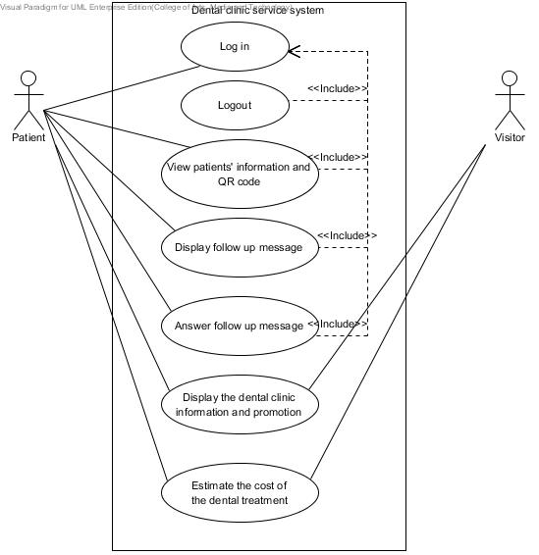

Figure 1: Dental clinic services system patient use case diagram

#### 

#### 4.2.2 Dental clinic services system Use Case for Officer

**Officer**

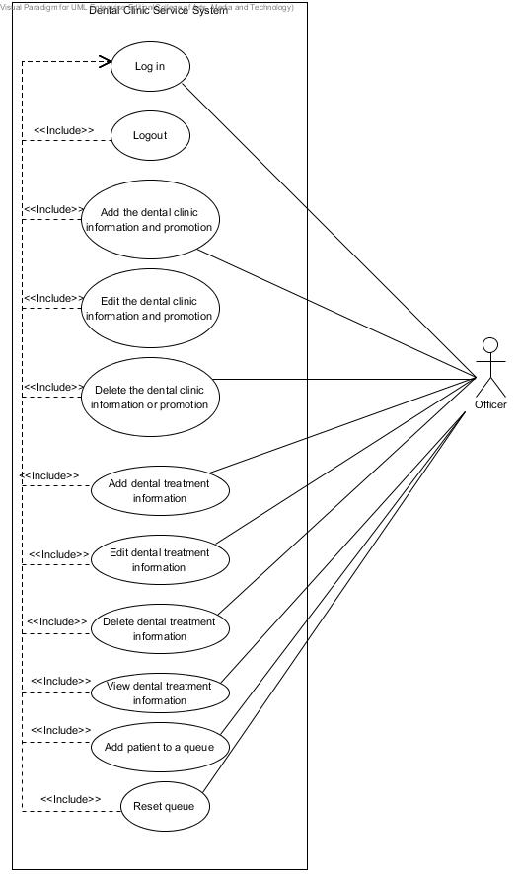

Figure 2: Dental clinic services system officer use case diagram

#### 4.2.3 Dental clinic services system Use Case for Dentist

**Dentist**

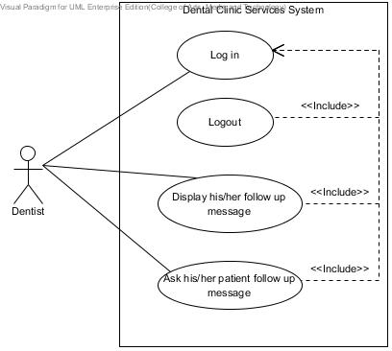

Figure 4: Dental clinic services system dentist use case diagram

### 4.3 Use case description

|  |  |  |  |
| --- | --- | --- | --- |
| Use Case ID: | UC-26 | | |
| **Use Case Name:** | View patients’ information and QR code(mobile) | | |
| **Created By:** | Worapun Wongkium | **Last Updated By:** | Kanokwan Maneeerat |
| **Date Created:** | 15/09/2014 | **Last Revision Date:** | 19/10/2014 |
| **Actors:** | Patient | | |
| **Description:** | Patient can view their own details and QR code. QR code you identify the patient at the clinic. | | |
| **Trigger:** | Patient select the patients’ details menu | | |
| **Preconditions:** | Patient is already logged into the application by using patientID and password | | |
| **Postconditions:** | Patient can view QR code and use QR code to identify his/her self at the clinic | | |
| **Normal Flow:** | 1. Patient selects “Details” menu in the mobile application 2. System shall connect with the database 3. System shall retrieve patients’ data including patientID, password, first name, last name, age, gender, address, tel., email, and treatment from the database 4. System shall generate the patient’s QR code in mobile application 5. System shall provide the patients’ information including QR code in view information page in mobile application 6. Patient can view QR code and use QR code to identify his/her self at the clinic | | |
| **Alternative Flows:** | N/A | | |
| **Exceptions:** | The patient will not have the QR code if he/she does not register to the dental clinic. | | |

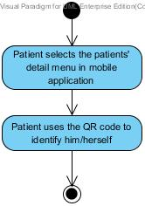

Figure 5: Display patients’ information and QR code in website [AD-22]

|  |  |  |  |
| --- | --- | --- | --- |
| Use Case ID: | UC-27 | | |
| **Use Case Name:** | View patients’ information and QR code(in website) | | |
| **Created By:** | Kanokwan Maneeerat | **Last Updated By:** | Kanokwan Maneeerat |
| **Date Created:** | 19/10/2014 | **Last Revision Date:** | 19/10/2014 |
| **Actors:** | Patient | | |
| **Description:** | Patient can view their own details and QR code. QR code you identify the patient at the clinic. | | |
| **Trigger:** | Patient select the patients’ details menu | | |
| **Preconditions:** | Patient is already logged into the website by using patientID and password | | |
| **Postconditions:** | Patient can view QR code | | |
| **Normal Flow:** | 1. Patient selects “Your Details” menu in the mobile application 2. System shall connect with the database 3. System shall retrieve patients’ data including patientID, password, first name, last name, age, gender, address, tel., email, and treatment from the database 4. System shall generate the patient’s QR code in the website 5. System shall provide the patients’ information including QR code in view information page in in the website | | |
| **Alternative Flows:** | N/A | | |
| **Exceptions:** | The patient will not has the QR code if he/she does not register to the dental clinic. | | |

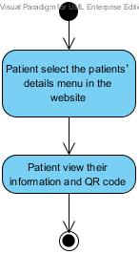

Figure 6: Display patients’ information and QR code in mobile application [AD-23]

|  |  |  |  |
| --- | --- | --- | --- |
| Use Case ID: | UC-28 | | |
| **Use Case Name:** | Add patient to a queue | | |
| **Created By:** | Kanokwan Maneeerat | **Last Updated By:** | Kanokwan Maneeerat |
| **Date Created:** | 19/10/2014 | **Last Revision Date:** | 19/10/2014 |
| **Actors:** | Officer | | |
| **Description:** | Officer can input patientID from QR code reader to add a patient into a queue | | |
| **Trigger:** | Officer select the add queue menu | | |
| **Preconditions:** | Officer is already logged into the website by using officerID and password | | |
| **Postconditions:** | Patient added to a queue | | |
| **Normal Flow:** | 1. Officer selects the add queue menu 2. System shall connect with the database 3. System shall provide page for checking an appointment date and time 4. System shall check time of input patientID and return the time of appointment 5. System shall provide the add queue page to add patient to a queue 6. System shall add patient into a queue | | |
| **Alternative Flows:** | 4a. System shall check time of input patientID and return “Not today” for not match date   1. System shall provide check time result page   4b. System shall check time of input patientID and return “No appointment” for the patientID that is not appointed   1. System shall provide check time result page   4c. System shall check time of input patientID and return “You’re missed” for the patientID that is late   1. System shall provide check time result page | | |
| **Exceptions:** | System will not connect to the database and deliver information if there is no internet connection. | | |

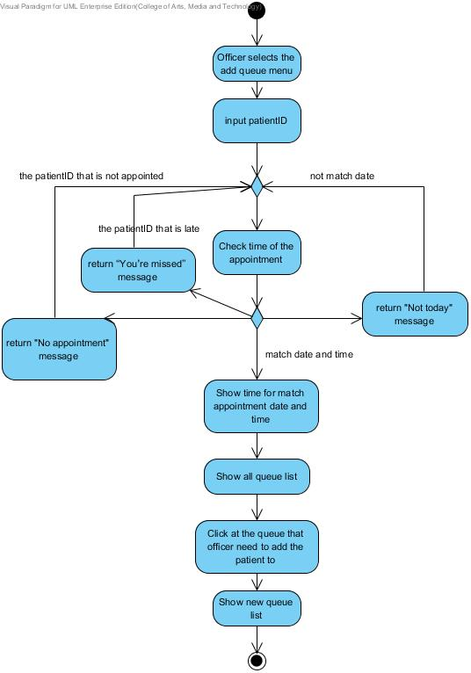

Figure 7: Add patient to a queue [AD-24]

|  |  |  |  |
| --- | --- | --- | --- |
| Use Case ID: | UC-29 | | |
| **Use Case Name:** | Reset queue | | |
| **Created By:** | Kanokwan Maneeerat | **Last Updated By:** | Kanokwan Maneeerat |
| **Date Created:** | 19/10/2014 | **Last Revision Date:** | 19/10/2014 |
| **Actors:** | Officer | | |
| **Description:** | Officer can reset a queue every end of the day to clear the queue for the next day | | |
| **Trigger:** | Officer select the reset queue button in the add queue page | | |
| **Preconditions:** | Officer is already logged into the website by using officerID and password | | |
| **Postconditions:** | A queue is empty | | |
| **Normal Flow:** | 1. Officer select the reset queue button in the add queue page 2. System shall provide the page for reset a queue 3. System shall connect with the database 4. Officer select the confirm button 5. System shall set all queue to be empty | | |
| **Alternative Flows:** | 4a. Officer not select confirm button   1. System shall provide the add queue page to add patient to a queue | | |
| **Exceptions:** | System will not connect to the database and deliver information if there is no internet connection. | | |

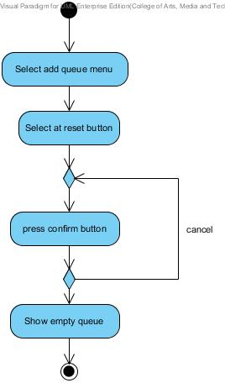

Figure 8: Reset queue [AD-25]

|  |  |  |  |
| --- | --- | --- | --- |
| Use Case ID: | UC-30 | | |
| **Use Case Name:** | Display his/her follow up message | | |
| **Created By:** | Worapun Wongkium | **Last Updated By:** |  |
| **Date Created:** | 15/09/2014 | **Last Revision Date:** | 14/10/2014 |
| **Actors:** | Dentist | | |
| **Description:** | Dentist can view his/her patient follow up message as a list | | |
| **Trigger:** | Dentist select dent follow up page | | |
| **Preconditions:** | Dentist is already logged into the website by using dentistID and password | | |
| **Postconditions:** | Dentist can view the patient’s follow up message as a list in dent follow up page | | |
| **Normal Flow:** | 1. Dentist select dent follow up page in the website 2. System shall provide the dent follow up page in the website 3. System shall connect with the database 4. System shall retrieve the patient’s message data including the answer from the database 5. System shall provide the patient’s message data as a list in the dent follow up page in the website 6. System shall retrieve the dentist’s message data including the question from the database 7. System shall provide the dentist’s message data as a list in the dent follow up page in the website 8. Dentist can view all his/her patient’s follow up message as alist in dent follow up page | | |
| **Alternative Flows:** | N/A | | |
| **Exceptions:** | System will not connect to the database and deliver information if there is no internet connection. | | |

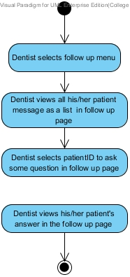

Figure 9: Display his/her follow up message [AD-26]

|  |  |  |  |
| --- | --- | --- | --- |
| Use Case ID: | UC-31 | | |
| **Use Case Name:** | Post the question for following up with his/her patient | | |
| **Created By:** | Worapun Wongkium | **Last Updated By:** | Kanokwan Maneerat |
| **Date Created:** | 15/09/2014 | **Last Revision Date:** | 19/10/2014 |
| **Actors:** | Dentist | | |
| **Description:** | Dentist can post question to follow up his/her patient | | |
| **Trigger:** | Dentist select patientID in the list for asking | | |
| **Preconditions:** | Dentist is already logged into the website by using dentistID and password | | |
| **Postconditions:** | Dentist is already leave the question for following up his/her patient in dent follow up page | | |
| **Normal Flow:** | 1. Dentist select dent follow up page 2. System shall provide the dent follow up page in the website 3. System shall connect with the database 4. System shall retrieve the patient’s message data including the question and answer from the database 5. System shall provide the patient’s message data as a list in the dent follow up page in the website 6. Dentist select patientID to ask some question with his/her patient for following up 7. System shall provide the follow up form in the dent follow up page in the website 8. Dentist input the question in the form and press submit button 9. System shall add the dentist’s message data including question and answer into the database 10. System shall update follow up table in the database 11. Dentist enter into the dent follow up page 12. System shall retrieve the dentist’s message data including the question from the database 13. System shall provide the dentist’s message data as a list in the dent follow up page in the website 14. Dentist can view his/her status that is the question is posted or not 15. Dentist can view his/her patient answer’s status that is patient already answer or not | | |
| **Alternative Flows:** | 8a. Dentist presses submit button and some field is empty.   1. System shall show error message “Please fill out this field” for any field that requires being not empty 2. Go back to normal flow 8   14a. Patient can view his/her status that is the answer is posted or not   1. System shall return true if the question is already save 2. System shall return false if the question is not saved yet   15a. Patient can view his/her dentists question’s status that is dentist is already post or not   1. System shall return true if the answer is already save 2. System shall return false if the answer is not saved yet | | |
| **Exceptions:** | System will not connect to the database and deliver information if there is no internet connection. | | |

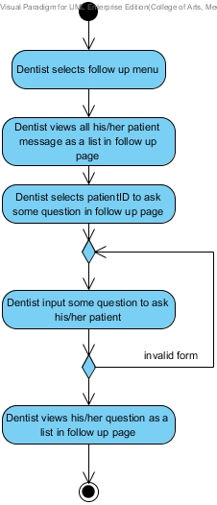

Figure 10: Post the question for following up with his/her patient [AD-27]

|  |  |  |  |
| --- | --- | --- | --- |
| Use Case ID: | UC-32 | | |
| **Use Case Name:** | Display follow up message | | |
| **Created By:** | Worapun Wongkium | **Last Updated By:** |  |
| **Date Created:** | 15/09/2014 | **Last Revision Date:** | 14/10/2014 |
| **Actors:** | Patient | | |
| **Description:** | Patient can view follow up massage that his/her dentist asked in thewebsiteas a list | | |
| **Trigger:** | Patient selects patient follow up page | | |
| **Preconditions:** | Patient is already logged into the website by using patientID and password | | |
| **Postconditions:** | Patient can view the dentist’s follow up message as a list patient follow up page | | |
| **Normal Flow:** | 1. Patient select the patient follow up page in the website 2. System shall connect with the database 3. System shall provide the follow up page in the website 4. System shall retrieve the patient’s message data including the the answer from the database 5. System shall provide the patient’s message data as a list in the patient follow up page in the website 6. System shall retrieve the dentist’s message data including the the question from the database 7. System shall provide the dentist’s message data as a list in the patient follow up page in the website 8. Patient can view all his/her dentist’s follow up message as a list in patient follow up page | | |
| **Alternative Flows:** | N/A | | |
| **Exceptions:** | System will not connect to the database and deliver information if there is no internet connection. | | |

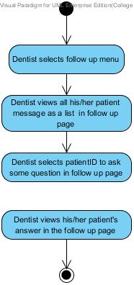

Figure 11: Display follow up message [AD-28]

|  |  |  |  |
| --- | --- | --- | --- |
| Use Case ID: | UC-33 | | |
| **Use Case Name:** | Answer follow up question | | |
| **Created By:** | Worapun Wongkium | **Created By:** | Kanokwan Maneerat |
| **Date Created:** | 15/09/2014 | **Date Created:** | 19/10/2014 |
| **Actors:** | Patient | | |
| **Description:** | Patient can answer follow up massage that his/her dentist asked in thewebsite | | |
| **Trigger:** | Patient select the question from his/her dentist for answer | | |
| **Preconditions:** | Patient is already logged into the website by using patientID and password | | |
| **Postconditions:** | Patient is already answer the question for following up his/her dentist in patient follow up page | | |
| **Normal Flow:** | 1. Patient selects patient follow up page 2. System shall connect with the database 3. System shall provide the patient follow up page in the website 4. System shall retrieve the dentist’s message data including the question from the database 5. System shall provide the dentist’s message data as a list in the patient follow up page in the website 6. Patient select the dentist’s question to answer 7. System shall provide the follow up form in the patient follow up page in the website 8. Patient input the answer in the form and press submit button 9. System shall add the patient’s message data including the answer into the database 10. System shall update follow up table in the database 11. Patient enter into the patient follow up page 12. System shall retrieve the patient’s message data including the answer from the database 13. System shall provide the patient’s message data as a list in the patient follow up page in the website 14. Patient can view his/her status that is the answer is posted or not 15. Patient can view his/her dentists question’s status that is dentist is already post or not | | |
| **Alternative Flows:** | 8a. Patient presses submit button and some field is empty.   1. System shall show error message “Please fill out this field” for any field that requires being not empty 2. Go back to normal flow 8   14a. Patient can view his/her status that is the answer is posted or not   1. System shall return true if the question is already save 2. System shall return false if the question is not saved yet   15a. Patient can view his/her dentists question’s status that is dentist is already post or not   1. System shall return true if the answer is already save 2. System shall return false if the answer is not saved yet | | |
| **Exceptions:** | System will not connect to the database and deliver information if there is no internet connection. | | |

* 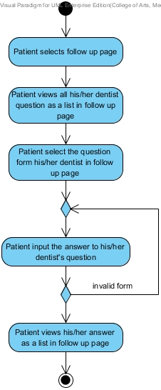

Figure 12: Answer follow up question [AD-29]

|  |  |  |  |
| --- | --- | --- | --- |
| Use Case ID: | UC-34 | | |
| **Use Case Name:** | Display follow up message (mobile application) | | |
| **Created By:** | Worapun Wongkium | **Last Updated By:** |  |
| **Date Created:** | 15/09/2014 | **Last Revision Date:** | 14/10/2014 |
| **Actors:** | Patient | | |
| **Description:** | Patient can view follow up massage that his/her dentist asked in mobileapplicationas a list | | |
| **Trigger:** | Patient selects follow up menu | | |
| **Preconditions:** | Patient is already logged into the mobile application by using patientID and password | | |
| **Postconditions:** | Patient can view the dentist’s follow up message as a list patient follow up page | | |
| **Normal Flow:** | 1. Patient select the follow up menu in the mobile application 2. System shall connect with the database 3. System shall provide the follow up page in the mobile application 4. System shall retrieve the patient’s message data including the the answer from the database 5. System shall retrieve the dentist’s message data including the question from the database 6. System shall provide the patient’s message data as a list in the follow up page in the mobile application 7. System shall provide the dentist’s message data as a list in the follow up page in the mobile application 8. Patient can view all his/her dentist’s follow up message as a list in follow up pagein mobile application | | |
| **Alternative Flows:** | N/A | | |
| **Exceptions:** | System will not connect to the database and deliver information if there is no internet connection. | | |

* 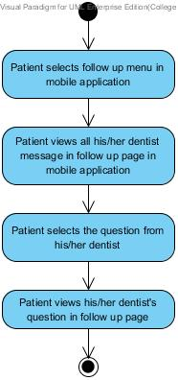
* Figure 13: Display follow up message [AD-30]

|  |  |  |  |
| --- | --- | --- | --- |
| Use Case ID: | UC-35 | | |
| **Use Case Name:** | Answer follow up question (mobile application) | | |
| **Created By:** | Worapun Wongkium | **Last Updated By:** | Kanokwan Maeerat |
| **Date Created:** | 15/09/2014 | **Last Revision Date:** | 19/10/2014 |
| **Actors:** | Patient | | |
| **Description:** | Patient can answer view follow up massage that his/her dentist asked inmobile applicationas a list | | |
| **Trigger:** | Patient select the question from his/her dentist for answer | | |
| **Preconditions:** | Patient is already logged into the website by using patientID and password | | |
| **Postconditions:** | Patient is already answer the question for following up with his/her dentist in follow up page | | |
| **Normal Flow:** | 1. Patient selects patient follow up page 2. System shall connect with the database 3. System shall provide the follow up page in the mobile application 4. System shall retrieve the dentist’s message data including the question and answer from the database 5. System shall provide the dentist’s message data as a list in the follow up page in the mobile application 6. Patient select the dentist’s question to answer 7. System shall provide the follow up form in the follow up page in the mobile application 8. Patient input the answer in the form and press submit button 9. System shall add the patient’s message data including question and answer into the database 10. System shall update follow up table in the database 11. Patient enter into the patient follow up page 12. System shall retrieve the patient’s message data including the question and answer from the database 13. System shall provide the patient’s message data as a list in the follow up page in the mobile application 14. Patient can view his/her status that is the answer is posted or not 15. Patient can view his/her dentists question’s status that is dentist is already post or not | | |
| **Alternative Flows:** | 8a. Patient presses submit button and some field is empty.   1. System shall show error message “Please fill out this field” for any field that requires being not empty 2. Go back to normal flow 8   14a. Patient can view his/her status that is the answer is posted or not   1. System shall return true if the question is already save 2. System shall return false if the question is not saved yet   15a. Patient can view his/her dentists question’s status that is dentist is already post or not   1. System shall return true if the answer is already save 2. System shall return false if the answer is not saved yet | | |
| **Exceptions:** | System will not connect to the database and deliver information if there is no internet connection. | | |

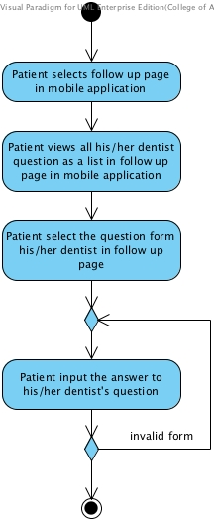

Figure 14: Answer follow up question in mobile application [AD-31]

|  |  |  |  |
| --- | --- | --- | --- |
| Use Case ID: | UC-36 | | |
| **Use Case Name:** | Display dental clinic informationand promotion(website**)** | | |
| **Created By:** | Worapun Wongkium | **Last Updated By:** |  |
| **Date Created:** | 15/09/2014 | **Last Revision Date:** | 14/10/2014 |
| **Actors:** | Patient | | |
| **Description:** | Patient can view the dental clinic information in the information and promotion page in the website | | |
| **Trigger:** | Patient selects information and promotion page | | |
| **Preconditions:** | Patient enter to the dental clinic website | | |
| **Postconditions:** | Patient can view the dental clinic information in the website | | |
| **Normal Flow:** | 1. Patient selects information and promotion page 2. System shall connect with the database 3. Patient selects some dental clinic information to view 4. System shall retrieve the dental clinic information data including the description from the database 5. System shall retrieve the dental clinic promotion data including the description from the database 6. System shall provide the dental clinic promotion’s data and information’s data in the information and promotion page in the website 7. Patient can view the dental clinic information in the website | | |
| **Alternative Flows:** | N/A | | |
| **Exceptions:** | System will not connect to the database and deliver information if there is no internet connection. | | |

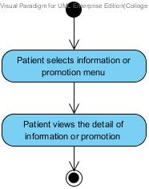

Figure 15: Display dental clinic informationand promotion in website [AD-32]

|  |  |  |  |
| --- | --- | --- | --- |
| **Use Case ID:** | UC-37 | | |
| **Use Case Name:** | Display dental clinic information and promotion (mobile application) | | |
| **Created By:** | Worapun Wongkium | **Last Updated By:** | Worapun Wongkium |
| **Date Created:** | 15/09/2014 | **Last Revision Date:** | 14/10/2014 |
| **Actors:** | Patient | | |
| **Description:** | Patient can view the dental clinic information in the information and promotion page in the mobile application | | |
| **Trigger:** | Patient selects information and promotion page | | |
| **Preconditions:** | Patient enter to the dental clinic mobile application | | |
| **Postconditions:** | Patient can view the dental clinic information in the mobile application | | |
| **Normal Flow:** | 1. Patient selects information and promotion page 2. System shall connect with the database 3. System shall provide the dental clinic information and promotion page in the mobile application 4. Patient selects some dental clinic information to view 5. System shall retrieve the dental clinic information data including the description from the database 6. System shall retrieve the dental clinic promotion data including the description from the database 7. System shall provide the dental clinic promotion’s data and promotion in the information and promotion page in mobile application 8. Patient can view the dental clinic information in the mobile application | | |
| **Alternative Flows:** | N/A | | |
| **Exceptions:** | System will not connect to the database and deliver information if there is no internet connection. | | |

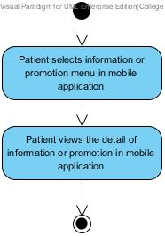

Figure 16: Display dental clinic informationand promotion in mobile application [AD-33]

|  |  |  |  |
| --- | --- | --- | --- |
| Use Case ID: | UC-38 | | |
| **Use Case Name:** | Add dental clinic information | | |
| **Created By:** | Worapun Wongkium | **Last Updated By:** |  |
| **Date Created:** | 15/09/2014 | **Last Revision Date:** | 14/10/2014 |
| **Actors:** | Officer | | |
| **Description:** | Officer can add new dental clinic information into the database | | |
| **Trigger:** | Officer select create dental clinic information menu | | |
| **Preconditions:** | Officer is already logged in to the website by using officerID and password | | |
| **Postconditions:** | Officer views all of the dental clinic information data as a list in all information and promotion page | | |
| **Normal Flow:** | 1. Officer selects create dental clinic information menu 2. System shall connect with the database 3. System shall provide the create information and promotion page 4. Officer input the dental clinic information including information topic, description into the database and press submit 5. System shall add dental clinic information’s data including dental information description into the database 6. System shall update information and promotion table in the database 7. Officer enters to the all information and promotion page 8. System shall retrieve the dental clinic information data including the description from the database 9. System shall provide the dental information and promotion as a list in all information and promotion page 10. Officer can view all the dental information and promotion as a list in all information and promotion page | | |
| **Alternative Flows:** | 4a. Patient presses submit button and some field is empty.   1. System shall show error message “Please fill out this field” for any field that requires being not empty 2. Go back to normal flow 4 | | |
| **Exceptions:** | System will not connect to the database and deliver information if there is no internet connection. | | |

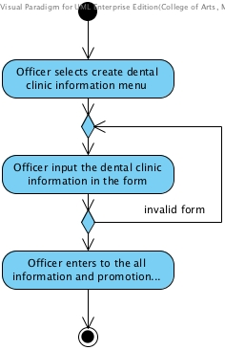

Figure 17: Add dental clinic information [AD-34]

|  |  |  |  |
| --- | --- | --- | --- |
| Use Case ID: | UC-39 | | |
| **Use Case Name:** | Edit dental clinic information | | |
| **Created By:** | Worapun Wongkium | **Last Updated By:** |  |
| **Date Created:** | 15/09/2014 | **Last Revision Date:** | 14/10/12014 |
| **Actors:** | Officer | | |
| **Description:** | Officer can edit the dental clinic information in the database | | |
| **Trigger:** | Officer select edit function in the all information and promotion page | | |
| **Preconditions:** | Officer is already logged in to the website by using officerID and password | | |
| **Postconditions:** | Officer views all dental clinic information as a list in all information and promotion page | | |
| **Normal Flow:** | 1. Officer selects edit function in all information and promotion page 2. System shall connect with the database 3. System shall retrieve the dental clinic information data including the description from the database 4. System shall provide the dental information’s data in the edit information and promotion form 5. Officer input some information for editing and press submit 6. System shall edit dental clinic information’s data in information and promotion table in the database 7. Officer enter to the all information and promotion page 8. System shall retrieve the dental clinic information data including the description from the database 9. System shall provide the dental information and promotion as a list in all information and promotion page 10. Officer can view all the dental information and promotion as a list in all information and promotion page | | |
| **Alternative Flows:** | 5a. Patient presses submit button and some field is empty.   1. System shall show error message “Please fill out this field” for any field that requires being not empty 2. Go back to normal flow 5 | | |
| **Exceptions:** | System will not connect to the database and deliver information if there is no internet connection. | | |

* 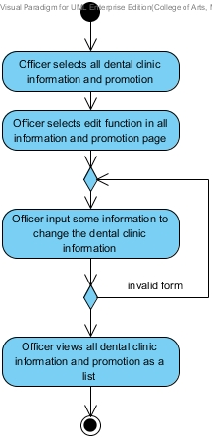

Figure 18: Edit dental clinic information [AD-35]

|  |  |  |  |
| --- | --- | --- | --- |
| Use Case ID: | UC-40 | | |
| **Use Case Name:** | Delete dental clinic information | | |
| **Created By:** | Worapun Wongkium | **Last Updated By:** |  |
| **Date Created:** | 15/09/2014 | **Last Revision Date:** | 14/10/2014 |
| **Actors:** | Officer | | |
| **Description:** | Officer can delete dental clinic information in the database | | |
| **Trigger:** | Officer select delete function in all information and promotion page | | |
| **Preconditions:** | Officer is already logged in to the website by using officerID and password | | |
| **Postconditions:** | Officer views all dental clinic information as a list in all information and promotion page | | |
| **Normal Flow:** | 1. Officer enter into the all information and promotion page 2. System shall connect with the database 3. System shall retrieve the dental clinic information data including the description from the database 4. System shall retrieve the dental clinic promotion data including the description from the database 5. System shall provide the dental information and promotion as a list in all information and promotion page 6. Officer selects delete function in all information and promotion page 7. System shall delete dental clinic information’s data from information and promotion table in the database 8. System shall update information and promotion table in the database 9. Officer enter to the all information and promotion page 10. System shall provide the dental information and promotion as a list in all information and promotion page 11. Officer can view all the dental information and promotion as a list in all information and promotion page | | |
| **Alternative Flows:** | N/A | | |
| **Exceptions:** | System will not connect to the database and deliver information if there is no internet connection. | | |

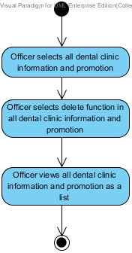

Figure 19: Delete dental clinic information [AD-36]

|  |  |  |  |
| --- | --- | --- | --- |
| Use Case ID: | UC-41 | | |
| **Use Case Name:** | Display dental clinic informationand promotion(website**)** | | |
| **Created By:** | Worapun Wongkium | **Last Updated By:** |  |
| **Date Created:** | 15/09/2014 | **Last Revision Date:** | 14/10/2014 |
| **Actors:** | Visitor | | |
| **Description:** | Visitor can view the dental clinic information in the information and promotion page in the website | | |
| **Trigger:** | Visitor selects information and promotion page | | |
| **Preconditions:** | Visitor enter to the dental clinic website | | |
| **Postconditions:** | Visitor can view the dental clinic information in the website | | |
| **Normal Flow:** | 1. Visitor selects information and promotion page 2. System shall connect with the database 3. Visitor selects some dental clinic information to view 4. System shall retrieve the dental clinic information data including the description from the database 5. System shall retrieve the dental clinic promotion data including the description from the database 6. System shall provide the dental clinic promotion’s data and information’s data in the information and promotion page in the website 7. Visitor can view the dental clinic information in the website | | |
| **Alternative Flows:** | N/A | | |
| **Exceptions:** | System will not connect to the database and deliver information if there is no internet connection. | | |

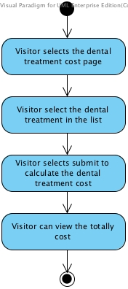

Figure 20: Display dental clinic information and promotion(website**)** [AD-37]

|  |  |  |  |
| --- | --- | --- | --- |
| Use Case ID: | UC-42 | | |
| **Use Case Name:** | Estimate the dental treatment cost (website) | | |
| **Created By:** | Worapun Wongkium | **Last Updated By:** |  |
| **Date Created:** | 15/09/2014 | **Last Revision Date:** | 14/10/2014 |
| **Actors:** | Patient | | |
| **Description:** | Patient can select the dental treatment to estimate the cost | | |
| **Trigger:** | Patient select the dental treatment cost page | | |
| **Preconditions:** | Patient enter to the dental clinic website | | |
| **Postconditions:** | Patient can view the totally cost that he/she selected | | |
| **Normal Flow:** | 1. Patient selects the dental treatment cost page 2. System shall connect with the database 3. System shall provide the cost estimation page in website 4. Patient select the dental treatment in the list 5. System shall retrieve the dental treatments’ data including dental treatment name, description and cost from the database 6. System shall provide the dental treatment data as a list in the cost estimation page 7. Patient press calculate button for estimating the dental treatment cost 8. System shall calculate the dental treatment cost 9. System shall provide the totally cost of dental treatment that the user selected 10. Patient can view the totally cost that he/she selected | | |
| **Alternative Flows:** | N/A | | |
| **Exceptions:** | System will not connect to the database and deliver information if there is no internet connection. | | |

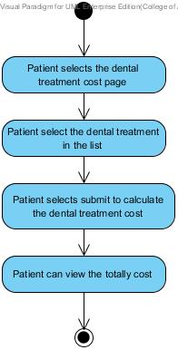

Figure 21: Estimate the dental treatment cost in website[AD-38]

|  |  |  |  |
| --- | --- | --- | --- |
| Use Case ID: | UC-43 | | |
| **Use Case Name:** | Estimate the dental treatment cost (mobile application) | | |
| **Created By:** | Worapun Wongkium | **Last Updated By:** |  |
| **Date Created:** | 15/09/2014 | **Last Revision Date:** | 14/10/2014 |
| **Actors:** | Patient | | |
| **Description:** | Patient can select the dental treatment to estimate the cost in the mobile application | | |
| **Trigger:** | Patient select the dental treatment cost page | | |
| **Preconditions:** | Patient enter to the dental clinic mobile application | | |
| **Postconditions:** | Patient can view the totally cost that he/she selected | | |
| **Normal Flow:** | 1. Patient selects the dental treatment cost page 2. System shall connect with the database 3. System shall provide the cost estimation page in mobile application 4. Patient select the dental treatment in the list 5. System shall retrieve the dental treatments’ data including dental treatment name, description and cost from the database 6. System shall provide the dental treatment data as a list in the cost estimation page in mobile application 7. Patient press calculate button for estimating the dental treatment cost 8. System shall calculate the dental treatment cost 9. System shall provide the totally cost of dental treatment that the user selected 10. Patient can view the totally cost that he/she selected | | |
| **Alternative Flows:** | N/A | | |
| **Exceptions:** | System will not connect to the database and deliver information if there is no internet connection. | | |

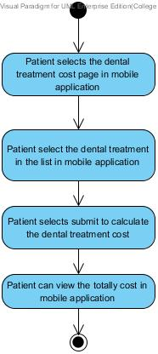

Figure 22: Estimate the dental treatment cost in mobile application[AD-39]

|  |  |  |  |
| --- | --- | --- | --- |
| Use Case ID: | UC-44 | | |
| **Use Case Name:** | Estimate the dental treatment cost (website) | | |
| **Created By:** | Worapun Wongkium | **Last Updated By:** |  |
| **Date Created:** | 15/09/2014 | **Last Revision Date:** | 14/10/2014 |
| **Actors:** | Visitor | | |
| **Description:** | Visitor can select the dental treatment to estimate the cost | | |
| **Trigger:** | Visitor select the dental treatment cost page | | |
| **Preconditions:** | Visitor enter to the dental clinic website | | |
| **Postconditions:** | Visitor can view the totally cost that he/she selected | | |
| **Normal Flow:** | 1. Visitor selects the dental treatment cost page 2. System shall connect with the database 3. System shall provide the cost estimation page in website 4. Visitor select the dental treatment in the list 5. System shall retrieve the dental treatments’ data including dental treatment name, description and cost from the database 6. System shall provide the dental treatment data as a list in the cost estimation page 7. Visitor press calculate button for estimating the dental treatment cost 8. System shall calculate the dental treatment cost 9. System shall provide the totally cost of dental treatment that the user selected 10. Visitor can view the totally cost that he/she selected | | |
| **Alternative Flows:** | N/A | | |
| **Exceptions:** | System will not connect to the database and deliver information if there is no internet connection. | | |



Figure 23: Estimate the dental treatment cost (website)[AD-40]

|  |  |  |  |
| --- | --- | --- | --- |
| Use Case ID: | UC-45 | | |
| **Use Case Name:** | Add dental treatment | | |
| **Created By:** | Worapun Wongkium | **Last Updated By:** |  |
| **Date Created:** | 15/09/2014 | **Last Revision Date:** | 14/10/2014 |
| **Actors:** | Officer | | |
| **Description:** | Officer can add new dental treatment into the database | | |
| **Trigger:** | Officer select create dental treatment menu | | |
| **Preconditions:** | Officer is already logged in to the website by using officerID and password | | |
| **Postconditions:** | Officer views all of the dental treatment data as a list in all dental treatment page | | |
| **Normal Flow:** | 1. Officer selects create dental clinic information menu 2. System shall connect with the database 3. System shall provide the create dental treatment page 4. Officer input the dental treatment including name, description, and cost into the database and press submit 5. System shall add the dental treatment information data including dental treatment name, description and cost into the database 6. System shall update the dental treatment table in the database 7. Officer enters to the all dental treatment page 8. System shall retrieve the dental treatments’ data including dental treatment name, description and cost from the database 9. System shall provide the dental treatment data as a list in the cost all dental treatment page 10. Officer can view all the dental treatment as a list in all dental treatment page | | |
| **Alternative Flows:** | 4a. Patient presses submit button and some field is empty.   1. System shall show error message “Please fill out this field” for any field that requires being not empty 2. Go back to normal flow 4 | | |
| **Exceptions:** | System will not connect to the database and deliver information if there is no internet connection. | | |

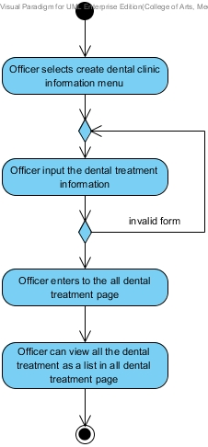

Figure 24: Add dental treatment [AD-41]

|  |  |  |  |
| --- | --- | --- | --- |
| Use Case ID: | UC-46 | | |
| **Use Case Name:** | Edit dental treatment | | |
| **Created By:** | Worapun Wongkium | **Last Updated By:** |  |
| **Date Created:** | 15/09/2014 | **Last Revision Date:** | 14/10/2014 |
| **Actors:** | Officer | | |
| **Description:** | Officer can edit the dental treatment in the database | | |
| **Trigger:** | Officer select edit function in the all dental treatment page | | |
| **Preconditions:** | Officer is already logged in to the website by using officerID and password | | |
| **Postconditions:** | Officer views all dental treatment as a list in all dental treatment page | | |
| **Normal Flow:** | 1. Officer selects edit function in all dental treatment page 2. System shall connect with the database 3. System shall retrieve the dental treatments’ data including dental treatment name, description and cost from the database 4. System shall provide the dental treatment data as a list in the cost all dental treatment page 5. Officer change some detail in the form for editing and press submit 6. System shall provide the dental treatment‘s data in the dental treatment edit form 7. System shall edit dental treatment information’s data in dental treatment table in the database 8. Officer enter to the all dental treatment page 9. System shall retrieve the dental treatments’ data including dental treatment name, description and cost from the database 10. System shall provide the dental treatment data as a list in the cost all dental treatment page 11. Officer can view all dental treatment as a list in all dental treatment page | | |
| **Alternative Flows:** | 5a. Patient presses submit button and some field is empty.   1. System shall show error message “Please fill out this field” for any field that requires being not empty 2. Go back to normal flow 5 | | |
| **Exceptions:** | System will not connect to the database and deliver information if there is no internet connection. | | |

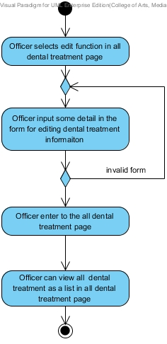

Figure 25: Edit dental treatment [AD-42]

|  |  |  |  |
| --- | --- | --- | --- |
| Use Case ID: | UC-47 | | |
| **Use Case Name:** | Delete dental treatment | | |
| **Created By:** | Worapun Wongkium | **Last Updated By:** |  |
| **Date Created:** | 15/09/2014 | **Last Revision Date:** | 14/10/2014 |
| **Actors:** | Officer | | |
| **Description:** | Officer can delete the dental treatment in the database | | |
| **Trigger:** | Officer select delete function in the all dental treatment page | | |
| **Preconditions:** | Officer is already logged in to the website by using officerID and password | | |
| **Postconditions:** | Officer views all dental treatment as a list in all dental treatment page | | |
| **Normal Flow:** | 1. Officer enter into the all dental treatment page 2. System shall connect with the database 3. System shall retrieve the dental treatments’ data including dental treatment name, description and cost from the database 4. System shall provide the dental treatment data as a list in the cost all dental treatment page 5. Officer selects delete function in all information and promotion page 6. System shall delete dental clinic information’s data from dental treatment table in the database 7. System shall update the dental treatment table in the database 8. Officer enter to the all dental treatment page 9. System shall provide the dental treatment data as a list in the cost all dental treatment page 10. Officer can view all the dental treatment as a list in all dental treatment page | | |
| **Alternative Flows:** | N/A | | |
| **Exceptions:** | System will not connect to the database and deliver information if there is no internet connection. | | |

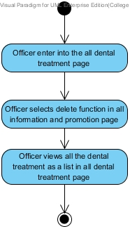

Figure 26: Delete dental treatment [AD-43]

|  |  |  |  |
| --- | --- | --- | --- |
| Use Case ID: | UC-48 | | |
| **Use Case Name:** | View dental treatment information | | |
| **Created By:** | Kanokwan Maneerat | **Last Updated By:** | Kanokwan Maneerat |
| **Date Created:** | 19/10/2014 | **Last Revision Date:** | 19/10/2014 |
| **Actors:** | Officer | | |
| **Description:** | Officer can view dental treatment information as a list in all treatment page | | |
| **Trigger:** | Officer select at all treatment menu | | |
| **Preconditions:** | Officer is already logged in to the website by using officerID and password | | |
| **Postconditions:** | Officer views all dental treatment as a list in all dental treatment page | | |
| **Normal Flow:** | 1. Officer select at all treatment menu 2. System shall connect with the database 3. System shall provide the dental treatment data as a list in all dental treatment pages | | |
| **Alternative Flows:** | N/A | | |
| **Exceptions:** | System will not connect to the database and deliver information if there is no internet connection. | | |

### D:\from desktop\senior project\progress 2\ad\view dental treatment information.jpg

Figure 27: Delete dental treatment [AD-44]